**EPSA TEAM - CAR N°81**

**REAL CASE**

**STEERING SYSTEM**

Objective: 20% cost reduction – consequences on performance

Parts and assemblies concerned with cost reduction:

|  |  |  |
| --- | --- | --- |
| Rack housing (ST 01007) | Steering column assembly (ST A0200) | Quick release steel sleeve (ST 03001) |
|  |  |  |

|  |  |
| --- | --- |
| Initial cost of Steering System | $ 342.53 |
| Final cost of Steering System | $ 273.40 |
| **Reduction percentage** | **20.2 %** |

The 20% cost reduction target is achieved, with a modification of:

* the rack housing
* the radial bearing in the steering column
* the quick release

Most of those modifications result in a weight increase, a diminution of the precision in the steering system, in a more complicated assembly or in less reliability. It will reduce the performance of the car but in a reasonnable way, not leading in a massive decrease of global performances.

**RACK HOUSING**

1. Modification of the material.

|  |  |  |  |  |
| --- | --- | --- | --- | --- |
| Initial Solution | Final Solution | Initial Cost (part) | Final Cost (part) | Saving (part) |
| Carbon fiber tube | Aluminium tube | $ 65.59 | $ 3.85 | Process: $ 61.74 |
| TOTAL |  |  |  | **$ 61.74** |

**STEERING COLUMN ASSEMBLY**

1. Modification of the bearing ball.

|  |  |  |  |  |
| --- | --- | --- | --- | --- |
| Initial Solution | Final Solution | Initial Cost (assembly) | Final Cost (assembly) | Saving (assembly) |
| Bearings: Øext. 42mm, thickness 7mm | Bearings: Øext. 37mm, thickness 7mm | $ 78.40 | $ 75.46 | Parts: $ 0.30  Materials: $ 2.64 |
| TOTAL |  |  |  | **$ 2.94** |

**QUICK RELEASE**

1. Modification of one of the parts.

|  |  |  |  |  |
| --- | --- | --- | --- | --- |
| Initial Solution | Final Solution | Initial Cost (part) | Final Cost (part) | Saving (part) |
| A shoulder on the part | No shoulder on the part | $ 12.88 | $ 8.43 | Materials: $ 0.32  Process: $ 4.13 |
| TOTAL |  |  |  | **$ 4.45** |

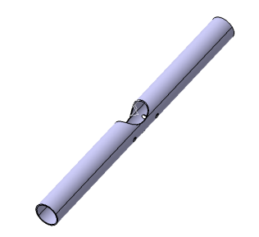**PART – RACK HOUSING**

**Idea**

* Modifying the material of the rack housing, from carbon fiber to aluminium.

**Effect on performance**

**Mass**

The aluminium tube is about 20 grams heavier. This increase in mass is very low hence it is not sufficient to correctly evaluate its impact on performance.

**Part quality**

The part is less strong. However, as shown in this image, the new part is resistant: the security coefficient is about 3.

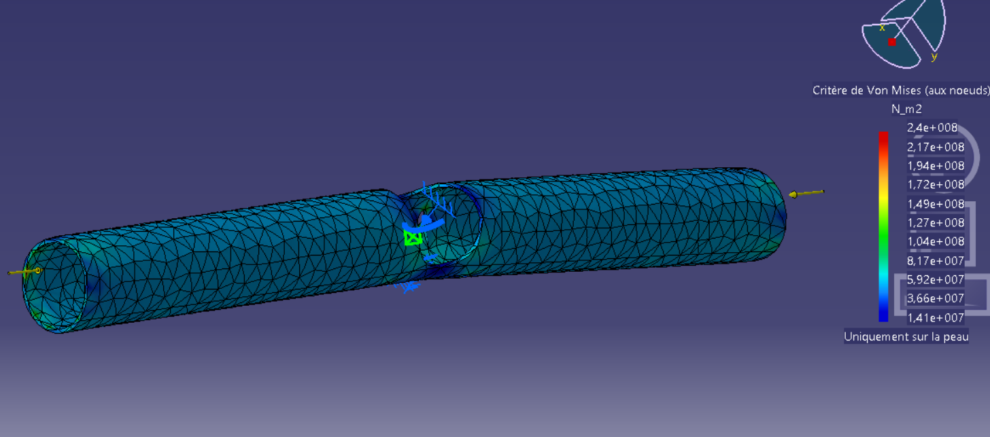

**Cost table**

*The total amount of the rack housing is decreased by 94 %, from 65.59 $ to 3.85 $.*

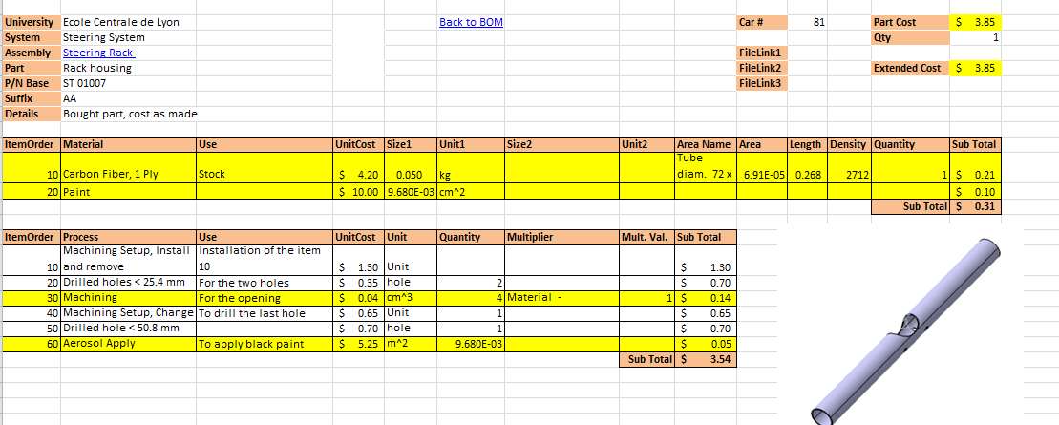

**ASSEMBLY – STEERING COLUMN ASSEMBLY**

**Idea**

* Modify the size of the bearing balls between the Steering Bore and the Steering Upper Shaft Pivot, from Ø42mm to Ø37mm.

**Effect on performance**

**Mass**

The bearings are slight lighter, but the difference is negligible.

**Part quality**

With the initial bearing, it was possible to apply vertical load of 800N on the top of the steering wheel, corresponding to the weight of our heavier driver. With the new bearing, it will be possible to only apply 650N on the steering wheel.

This modification will lead to a worse reliability and can have for consequence a hard spot while turning the steering wheel if the bearings are damaged.

A slight modification to the Steering Bore and Steering Bore Support have to be made to adapt them to the new bearings. The cost is cheaper of a few cents for these parts.

**Cost tables**

*The total amount of the steering column assembly is decreased by 4 %, from 78.40 $ to 75.46 $. This saving caused a diminution of the capacity of the bearings.*

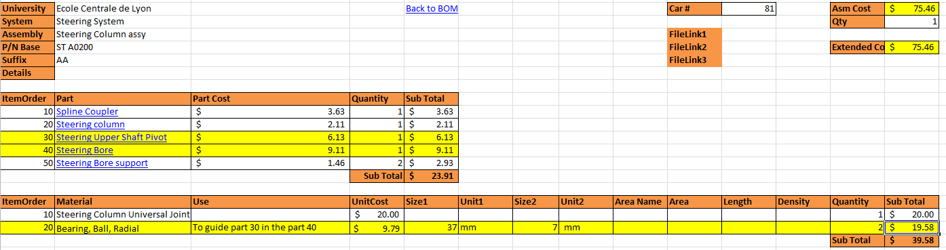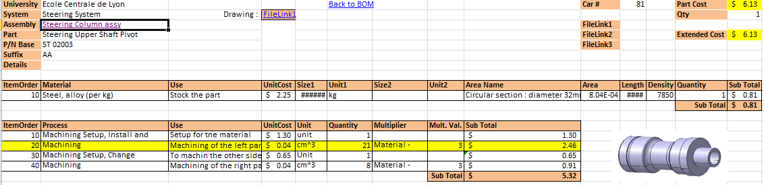 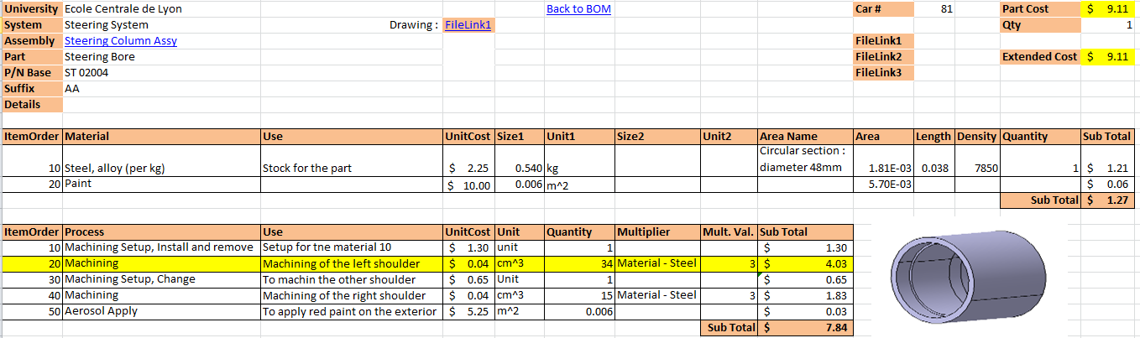

**PART – QUICK RELEASE STEEL SLEEVE**

**Idea**

Removing the shoulder on the quick release steel sleeve.

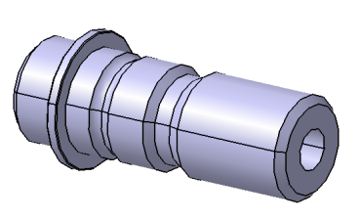

**Effect on performance**

Without this shoulder, it will be more complicated to position the Quick Release Steel Sleeve in the Steering Upper Shaft Pivot. Indeed a translation will be possible and during the welding its position will be less precise and the position control will harder. This will lead to a longer welding operation.

**Cost table**

*The total amount of the quick release steel sleeve is decreased by 35 %, from 12.88 $ to 8.43 $. This saving causes a worse positioning of the part in its housing.*

